Teacher Preparation Program
Daily Lesson Plan Model

Header
Name of the teacher candidate | Genesis A. Cartagena
Grade | 4th grade
Subject | English
Date | October 7, 2025
Unit | Unit 4.4: My Story: Exploring Figurative Language and the Writing Process
Theme | Figurative Language
Subtheme (Optional) | Why do writers use metaphors and similes?

Standard | Expectation | Indicator
Speaking, Listening, Language and Writing | 4.L.1, 4.S.1, 4.LA.2, 4.W.2 | 4.L.1.a, 4.LA.2.a

Concepts | Figurative language, Imagine, Metaphor and Simile
Skills | Identifying similes and metaphors, Brainstorming,
Academic Teaching Strategy | _____Exploration ___X__Conceptualization __X___Application  Other:

Objectives: After reviewing Figurative Language students will

Type of Objective  (verbs from Bloom) | Conceptual (concepts, principles, data, facts)  Understand what a simile is (a comparison using like or as)  Understand what a metaphor is (a direct comparison, stating something is something else) with minimal error |  | Procedural (processes, skills, strategies)  Writing the differences between Smilie and metaphor with minimal error. |  | Attitudinal (attitudes, values, norms)  Respect each other with minimal error.
Depth of Knowledge  (Webb) |  | Level I |  | Level I | X | Level I
Depth of Knowledge  (Webb) | X | Level II | X | Level II |  | Level II
Depth of Knowledge  (Webb) |  | Level III |  | Level III |  | Level III
Depth of Knowledge  (Webb) |  | Level IV |  | Level IV |  | Level IV

Initiative or Innovative Project
X | Equity and respect among all human beings |  | Cultural identity and interculturality
 | Education for environmental and ecological awareness |  | Entrepreneurship and innovation
 | Health awareness |  | Information and communication technology

Activities
Routines  The students and teacher will  - Take attendance  - Collaboratively discuss the day’s reflection  "A woman is like a teabag—you never know how strong she is until she gets in hot water." — Eleanor Roosevelt  Initial  The teacher will ask the students “What is figurative language? What is simile and metaphor” | Developing  After the teacher asks the students the question and discuss with them the importance the teacher will introduce the topic.  The teacher will discuss the PowerPoint of figurative language while stopping for questions to the students. | Closing  After the teacher is finished discussing the PowerPoint the teacher will hand out simile and metaphor worksheet.  Students will work on the assignment until the end of the class.

Cross-Curricular Integration
 | Spanish |  | Science |  | Technology
 | Mathematics |  | Other: _______________ |  | Home Economics
Fine arts (music, art, dance, theater) |  |  | Physical Education | Health
Dramatization |  |  | Rhythm | Environment
Representations |  |  | Movement | Diseases
Songs |  |  | Exercises | Self-esteem X
Construction |  |  | Marches | Interpersonal relationships
Simulations |  |  | Follow instructions X | Health
Dancing |  |  | Games | Healthy snacks
Dioramas (models) |  |  | Nature | Violence
Art Presentation |  |  | Cooperative Play | Gender equity
Genre Change |  |  | Reflect | Respect X

Assessment
Formative Assessment |  | Summative Assessment
 | Conceptual Map |  | Partial test
 | Targeted list |  | Comprehensive Examination
 | Reflective diary |  | Performance task
 | Open-ended questions |  | Oral report
 | Execution task |  | Written report
 | Creative work |  | Essay
 | Critical commentary |  | Project
 | Creative writing |  | Major Assignment
 | Group dynamic |  | Other:
X | Brainstorming |  | Other:
 | Debate |  | Other:
X | Assignment |  | Other:
 | Other: |  | Other:

Reasonable Accommodation or Curricular Modification
 | Staggered activities |  | Group research
 | Agendas |  | List of interest
X | Flexible seating |  | Multiple intelligences
X | Visual aid |  | Guiding questions
 | Folders |  | Learning contract
X | Extended time |  | Reading equipment
X | Accessible classrooms | X | Independent study
 | Formatting changes |  | Lecture recording
 | Alternate assignment |  | Alternate instruction format
X | Laptop access |  | Sign language interpretation
 | Printed materials |  | Assistance with note-taking
 | Testing accommodations |  | Reduced distractions
 | Assignment options |  | Text to speech technology
 | Progress log |  | Breaks
 | Preferential seating |  | Other:

Differentiated Instruction
 | Task adaptation |  | Additional examples
 | Flexible grouping |  | Additional time
 | Student choice |  | Individual attention
 | Songs/games | X | Flexible seating
X | Tiered assignments |  | Reader
 | Simplify steps |  | Change of location
 | Multiple intelligences |  | Other:

Materials
 | Notebook |  | Dictionary
 | Computer |  | Newspaper/magazine
 | Projector | X | Task sheet
 | Textbook Page |  | Test
 | Notebook p. |  | Slate
X | Other: PowerPoint |  | Whiteboard or chalkboard

Homework Assignment (optional): None

Reflection on the lesson (praxis): Reflect on what happened during class: your performance and the educational response of the students. How well did the class work with the plan and/or the proposed objectives? Could this lesson have been done better?

Observations: Note anything that happened that was relevant to the class (such as student issues, school-wide activities that affected the lesson timing, technology outages, high number of absences or tardies, who stayed on task and who struggled, who worked well and who did not, etc.).

Appendixes: Include all materials as appendixes.

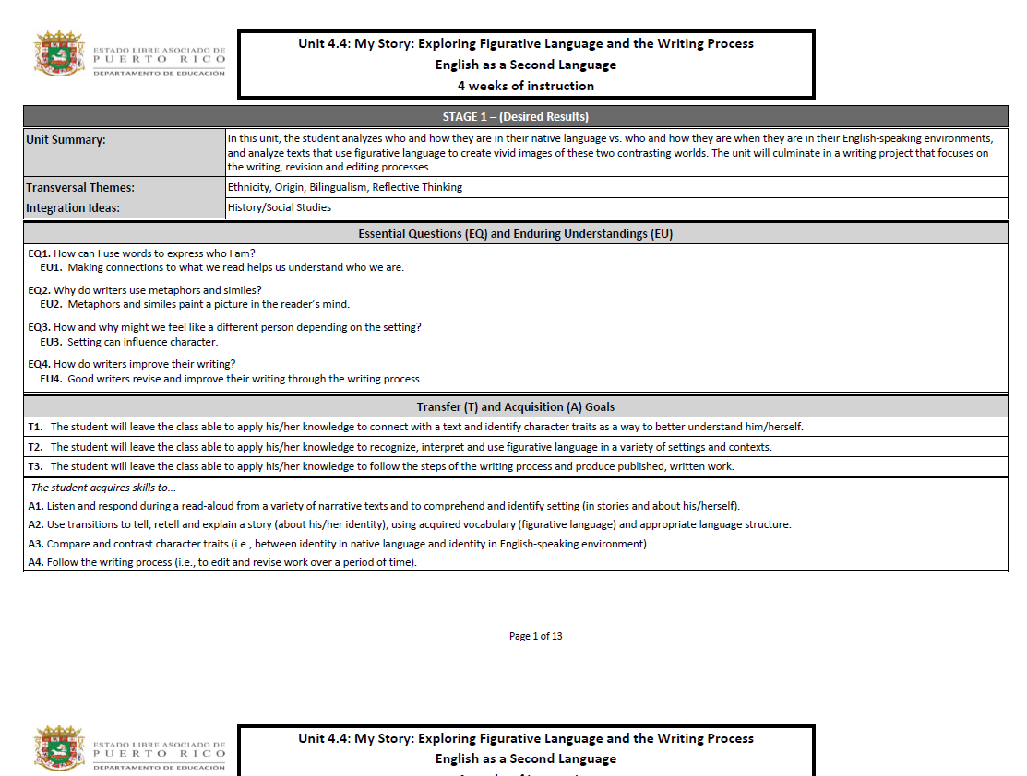

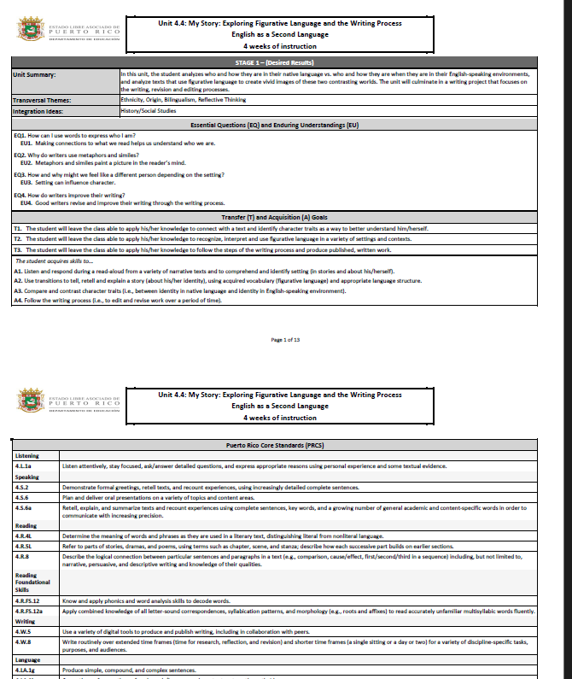
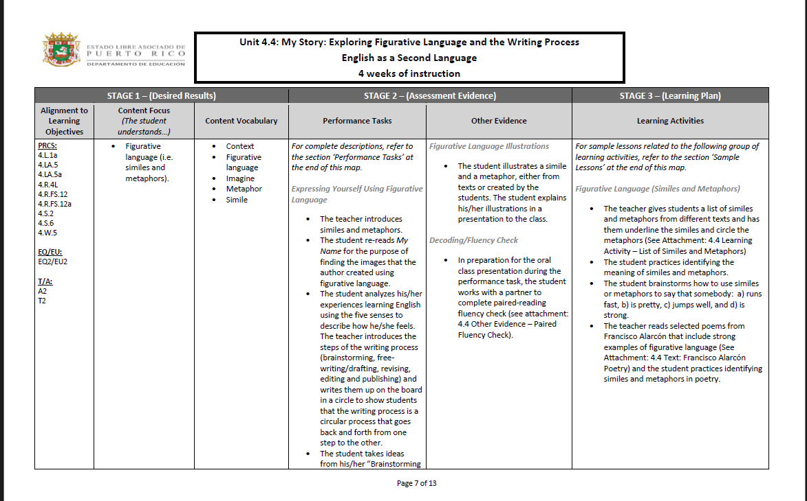
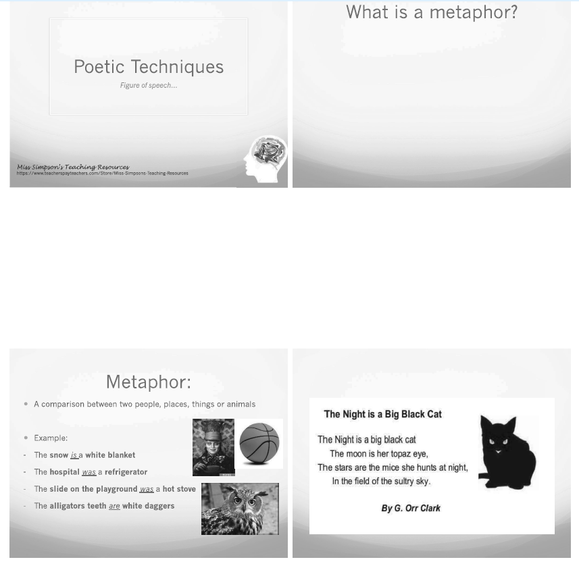

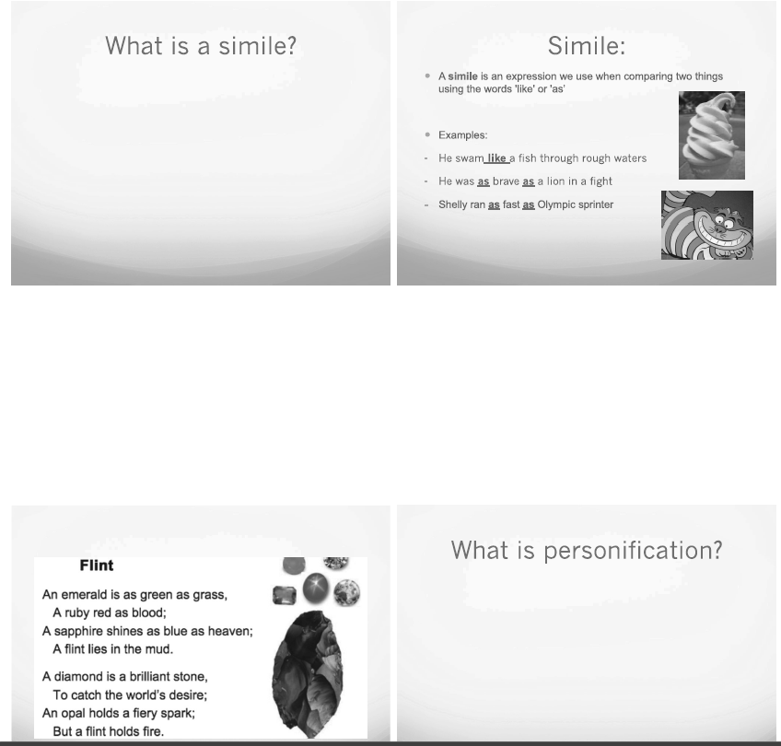
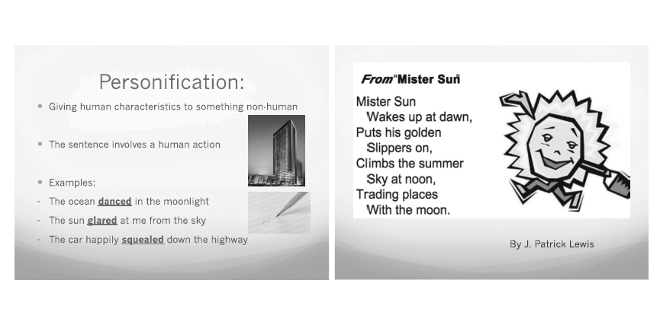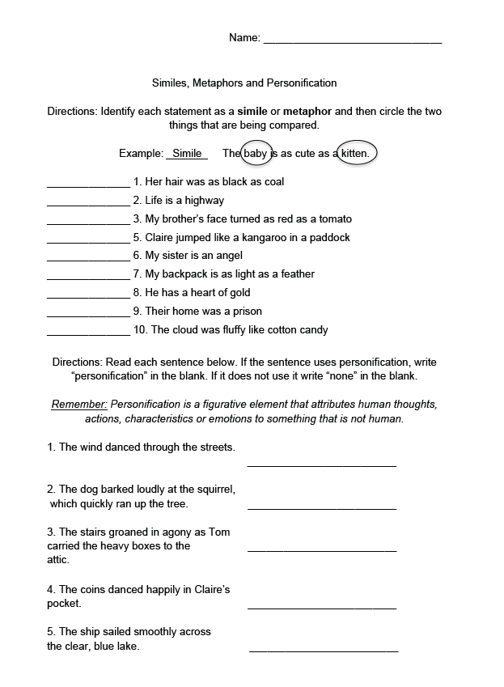

© Document developed at UPR Aguadilla by Professor Nydia E. Ugarte Avilés, Supervisor of Teaching Practice. Revised January 2017, integrating basic aspects of Circular Letter No. 03- 2016-2017 of the DEPR.
© Reviewed by Dr. Lissette Hernandez Villanueva according to Circular Letter 02-2019-2020 DEPR and Planning in Line (PeL) 2021, DEPR. August 2022
© Translated by Dr. Alison Torres Ramos, Spring 2023. Revised Fall 2024.

