Teacher Preparation Program
Daily Lesson Plan Model

Header
Name of the teacher candidate | Genesis Alondra Cartagena
Grade | 3rd Grade
Subject | English
Date | April 7,2023
Unit | 8
Theme | Weather and Climate
Subtheme (Optional) | How can we predict the unknown?

Standard | Expectation | Indicator
Speaking listening and language | 3.LS.2.1, 3.R.4, 3.R.2 | 3.R.4.1L, 3.R.2.1L

Concepts | Vocabulary words, Reading comprehension , Recounting story details. Hard g and soft g
Skills | Critical Thinking , Infering , Collaborative Discussion, Vocabulary development
Academic Teaching Strategy | _____Exploration __X___Conceptualization __X___Application  Other:

Objective: After reviewing context clues , hard and soft c , vocabulary words the students will be able to
Type of Objective  (verbs from Bloom) | Conceptual (concepts, principles, data, facts)  Objective: Distinguish the different definitions of the hard g and soft g.  Infer about the vocabulary and Spelling words of the week. |  | Procedural (processes, skills, strategies)  Objective:  Compare and contrast the different definitions of hard g and soft g.  Remember the spelling words and vocabulary words of the week with minimal errors. |  | Attitudinal (attitudes, values, norms)  Objective:  Participate in group discussions with minimal errors.  Be able to understand the vocabulary and spelling words on your own with minimal errors.
Depth of Knowledge  (Webb) |  | Level I |  | Level I |  | Level I
Depth of Knowledge  (Webb) | X | Level II |  | Level II | X | Level II
Depth of Knowledge  (Webb) |  | Level III | X | Level III |  | Level III
Depth of Knowledge  (Webb) |  | Level IV |  | Level IV |  | Level IV

Initiative or Innovative Project
X | Equity and respect among all human beings | X | Cultural identity and interculturality
X | Education for environmental and ecological awareness |  | Entrepreneurship and innovation
 | Health awareness |  | Information and communication technology

Activities
Routines  The students and the teacher will:  ⦁ Weather and Climate, pages 12-19 “Water Sky” and annotate for the main idea.  ⦁Recite the “Pledge of Allegiance” and the class pledge after the second bell rings.  ⦁Find who is the lucky duck (student will help the teacher like an assistant)  ⦁Collaboratively discuss the day’s reflection:  “These are not snowflakes but whispers from the sky.”Anon.  Initial  The teacher will introduce the spelling words and vocabulary words of the week. The spelling words will be about the hard g and soft g | Developing  The teacher will explain what is the soft g and hard g and give examples of how they sound.  The teacher will read with the students Weather and Climate, pages 12-19 “Water Sky” and ask the students reading comprehension questions such as “How were you able to distinguish important story details from unimportant ones?” | Closing  How did Lincoln’s mood change? (He started out “happy with purpose” but then began to panic when he learned things would not go as planned.)  Paragraph 10: What does Lincoln think of when he meets Kusiq? (Lincoln is reminded of Eskimos he has seen in old photographs and in a painting back home.)  Then the teacher will go to the second part of ELA.

Cross-Curricular Integration
 | Spanish | X | Science |  | Technology
 | Mathematics |  | Other: Social Studies |  | Home Economics
Fine arts (music, art, dance, theater) |  |  | Physical Education | Health
Dramatization |  |  | Rhythm | Environment X
Representations |  |  | Movement | Diseases
Songs |  |  | Exercises | Self-esteem
Construction |  |  | Marches | Interpersonal relationships
Simulations |  |  | Follow instructions | Health
Dancing |  |  | Games | Healthy snacks
Dioramas (models) |  |  | Nature | Violence
Art Presentation |  |  | Cooperative Play | Gender equity X
Genre Change |  |  | Reflect | Respect X

Assessment
Formative Assessment |  | Summative Assessment
 | Conceptual Map |  | Partial test
 | Targeted list |  | Comprehensive Examination
 | Reflective diary |  | Performance task
 | Open-ended questions |  | Oral report
 | Execution task |  | Written report
 | Creative work |  | Essay
X | Open ended questions |  | Project
 | Creative writing |  | Major Assignment
X | Group dynamic |  | Other:
 | Brainstorming |  | Other:
 | Debate |  | Other:
 | Assignment |  | Other:
 | Other: |  | Other:

Reasonable Accommodation or Curricular Modification
 | Staggered activities |  | Group research
X | Agendas |  | List of interest
 | Flexible seating |  | Multiple intelligences
X | Visual aid | X | Guiding questions
X | Folders |  | Learning contract
 | Extended time |  | Reading equipment
X | Accessible classrooms | X | Independent study
 | Formatting changes |  | Lecture recording
 | Alternate assignment |  | Alternate instruction format
X | Laptop access |  | Sign language interpretation
X | Printed materials |  | Assistance with note-taking
 | Testing accommodations |  | Reduced distractions
 | Assignment options |  | Text to speech technology
 | Progress log |  | Breaks
X | Preferential seating |  | Other:

Differentiated Instruction
X | Task adaptation |  | Additional examples
 | Flexible grouping |  | Additional time
 | Student choice | X | Individual attention
 | Songs/games |  | Flexible seating
 | Tiered assignments |  | Reader
 | Simplify steps |  | Change of location
 | Multiple intelligences |  | Other:

Materials
 | Notebook |  | Dictionary
X | Computer |  | Newspaper/magazine
 | Projector |  | Task sheet
X | Textbook ” “Weather and Climate, pages 12-19 “Water Sky” |  | Test
 | Notebook p. |  | Slate
 | Other: Youtube | X | Television

Homework Assignment (optional): None

Reflection on the lesson (praxis): Reflect on what happened during class: your performance and the educational response of the students. How well did the class work with the plan and/or the proposed objectives? Could this lesson have been done better?

Observations: Note anything that happened that was relevant to the class (such as student issues, school-wide activities that affected the lesson timing, technology outages, high number of absences or tardies, who stayed on task and who struggled, who worked well and who did not, etc.).

Appendixes: Include all materials as appendixes.

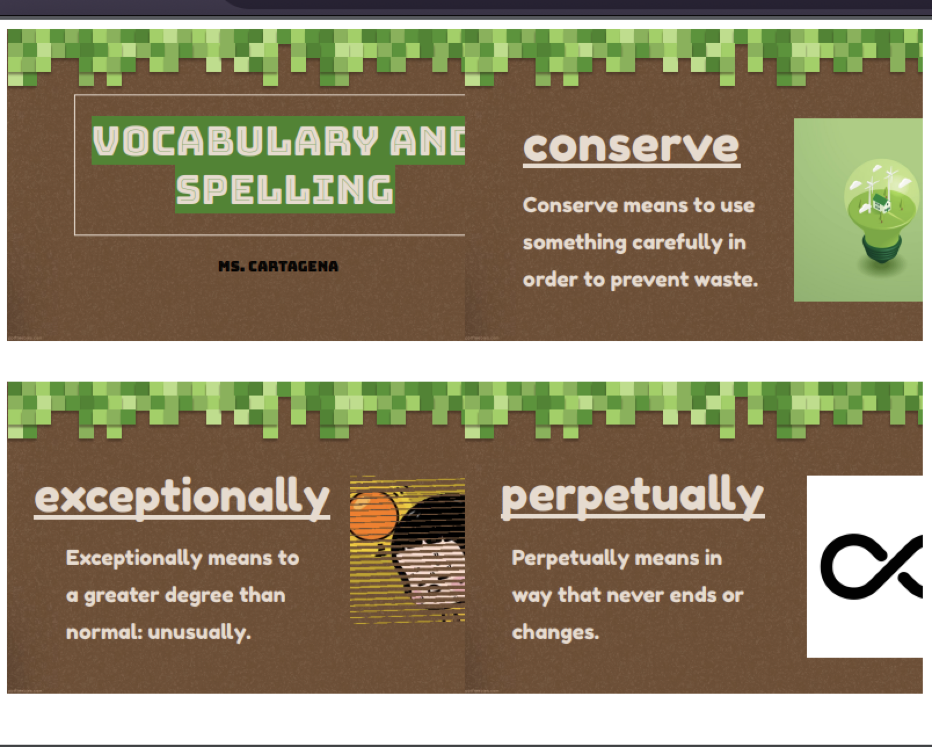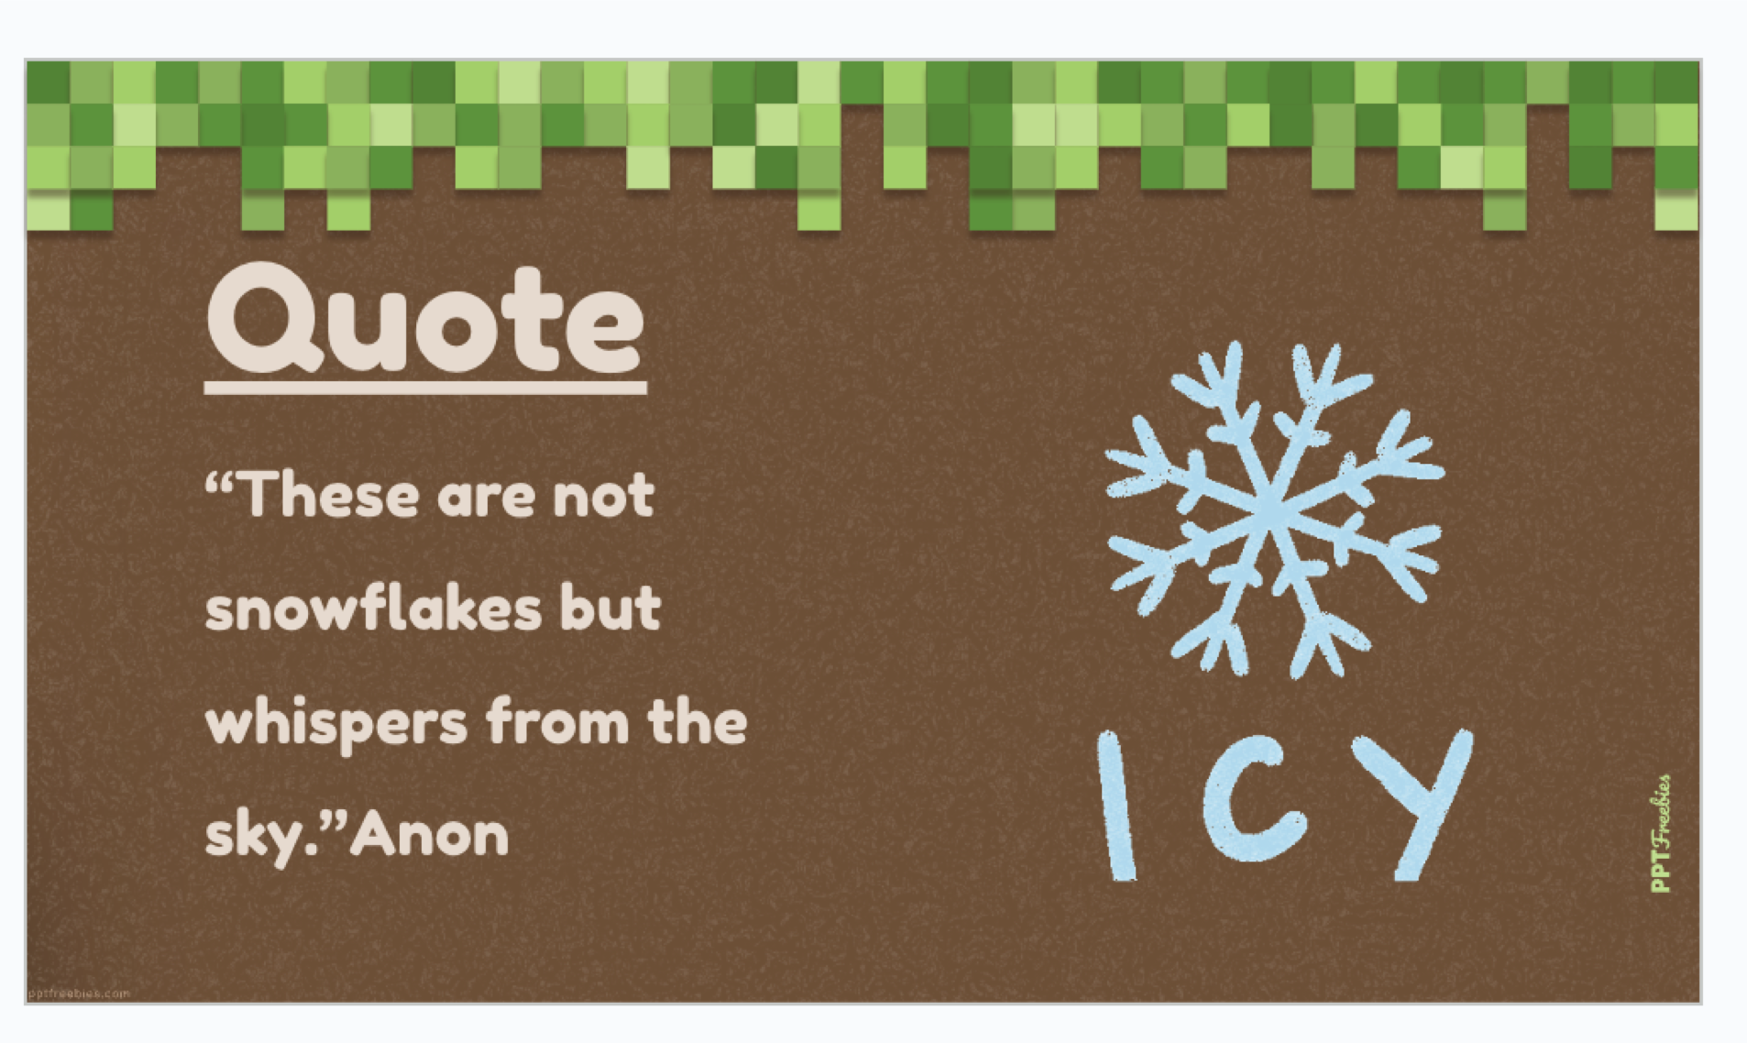
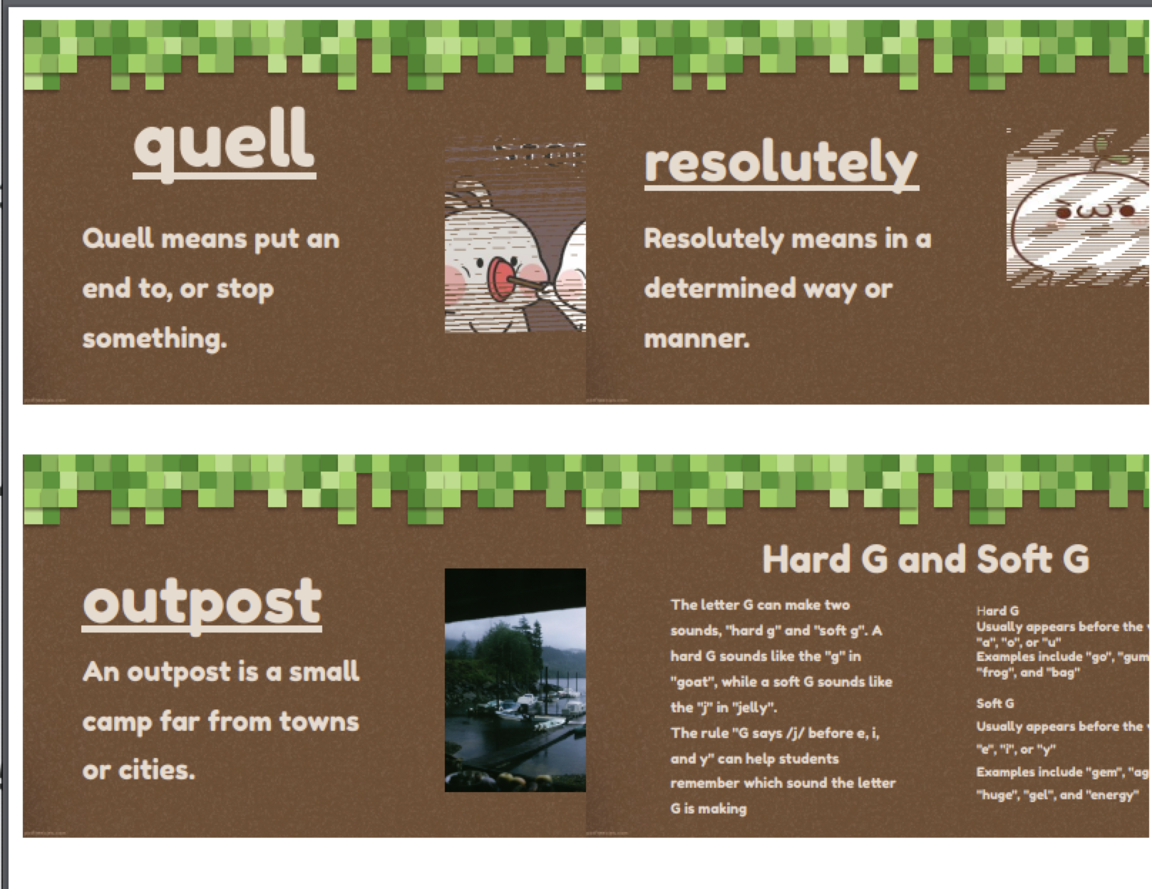
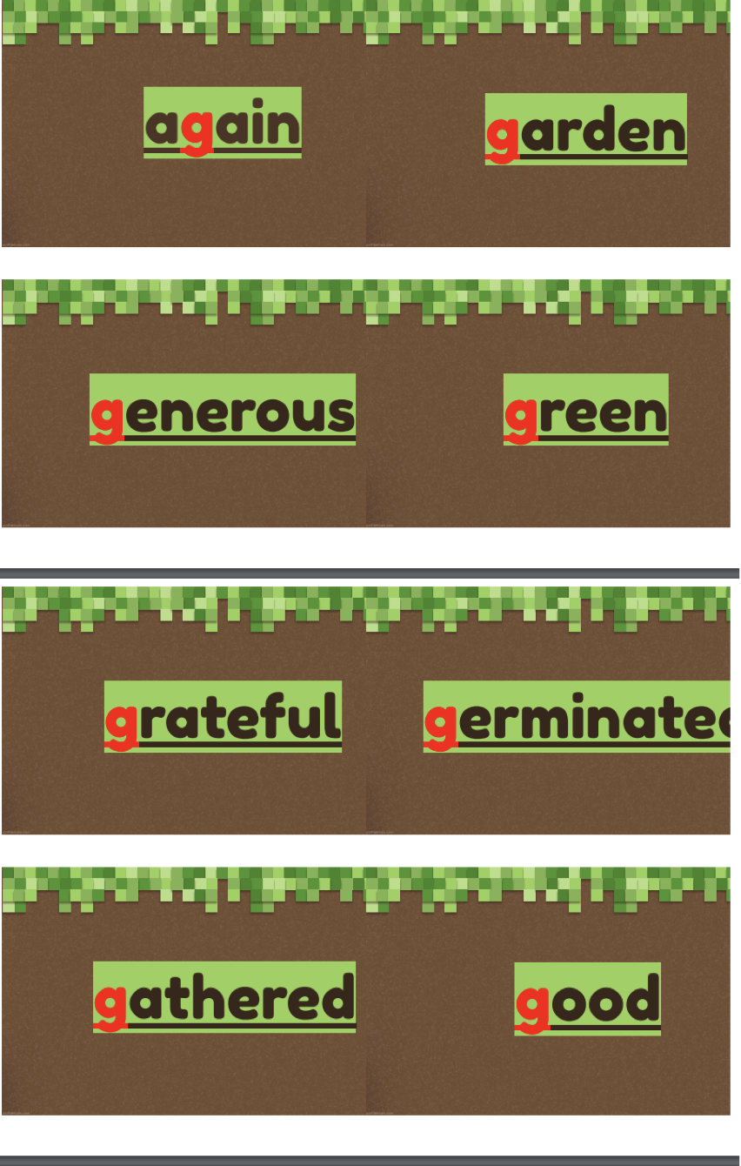
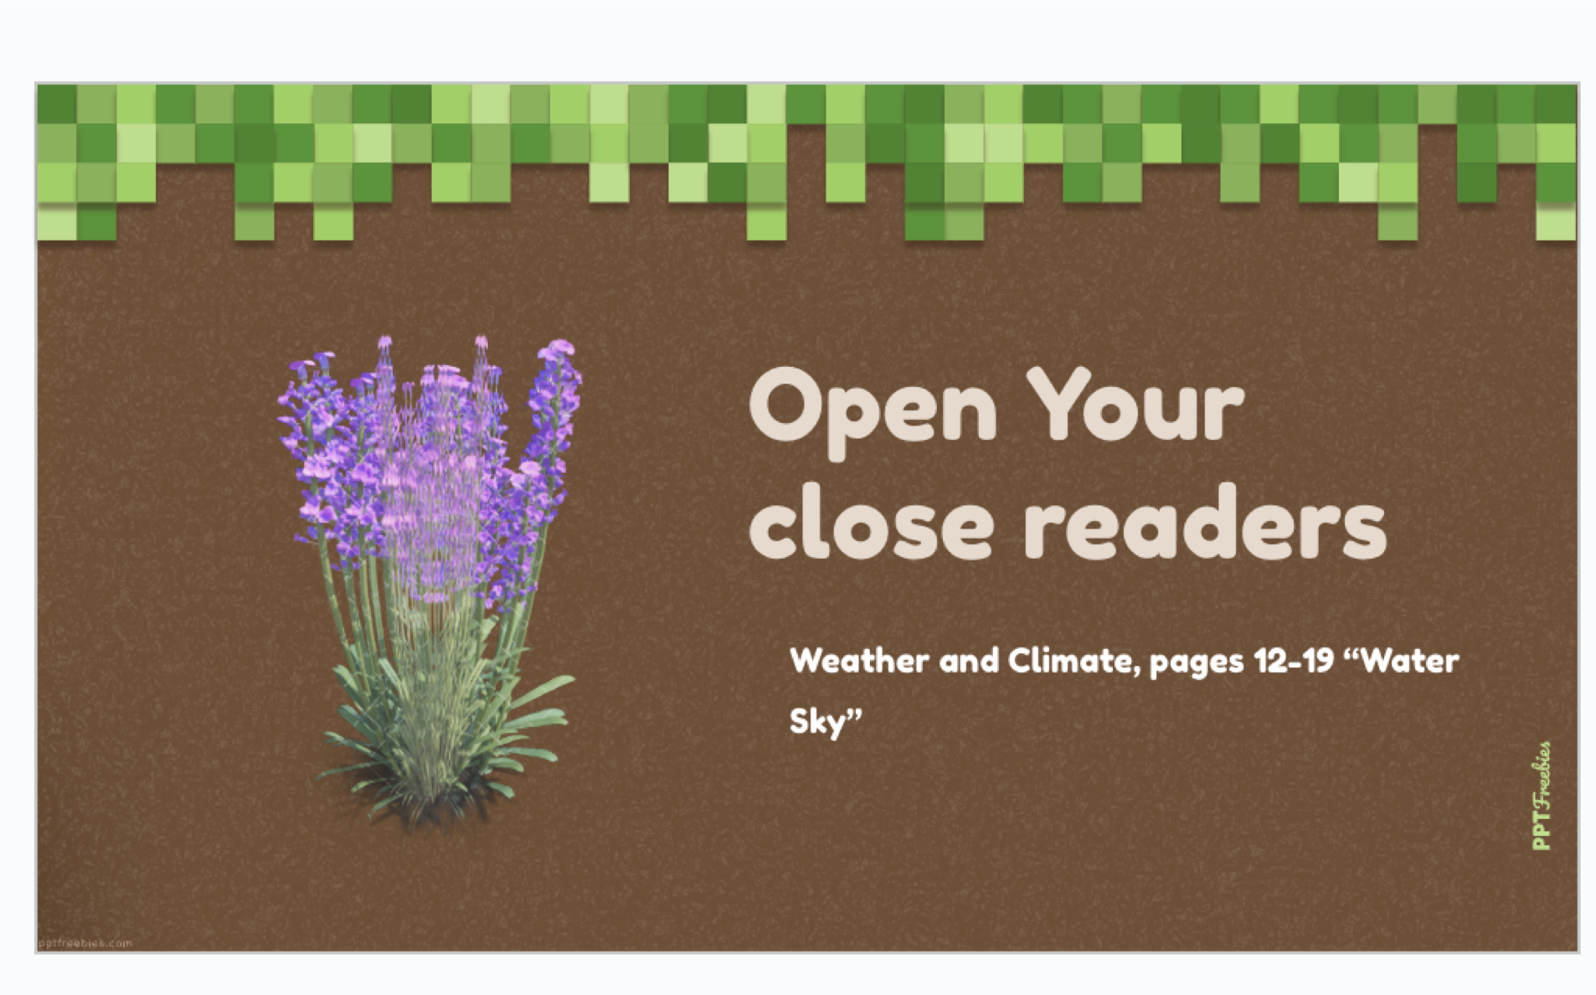
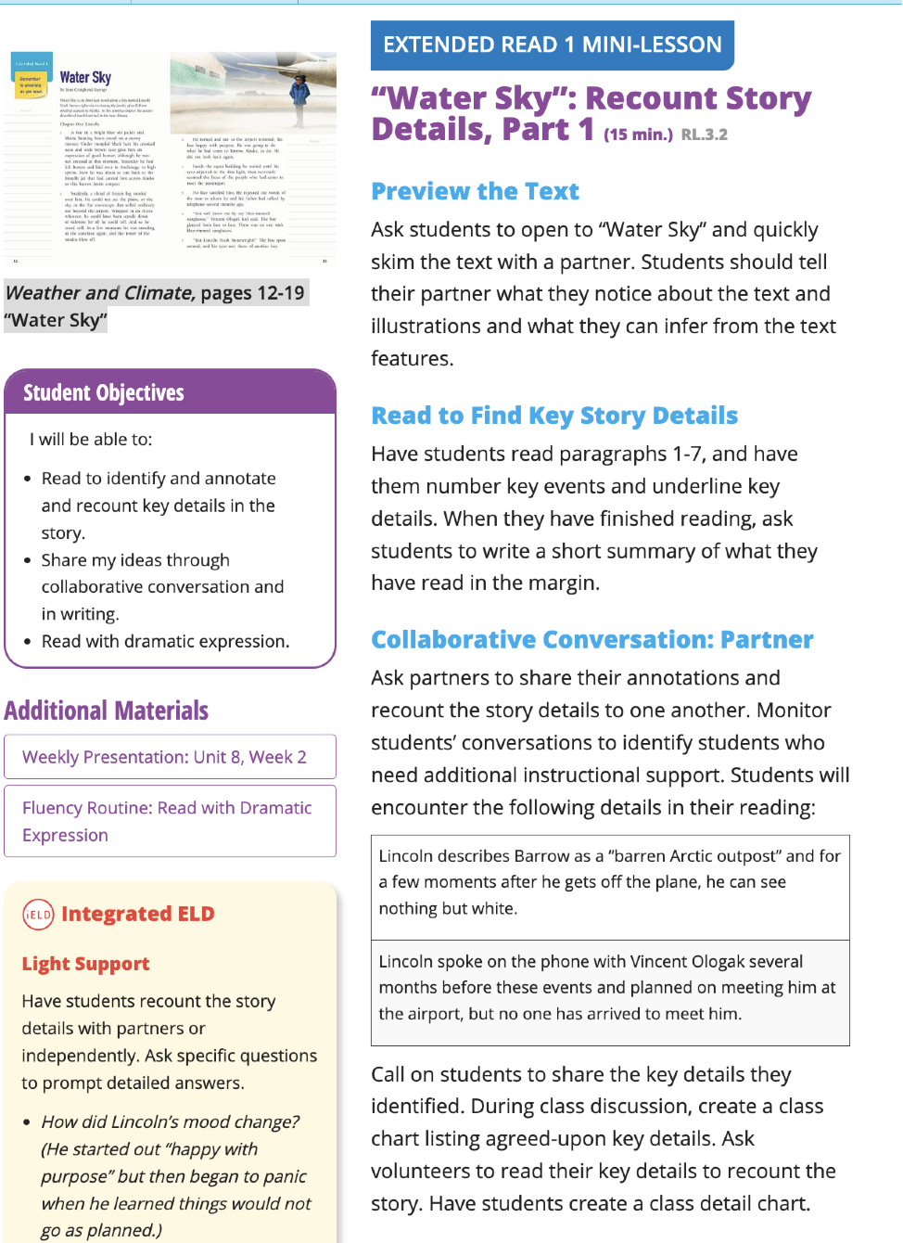
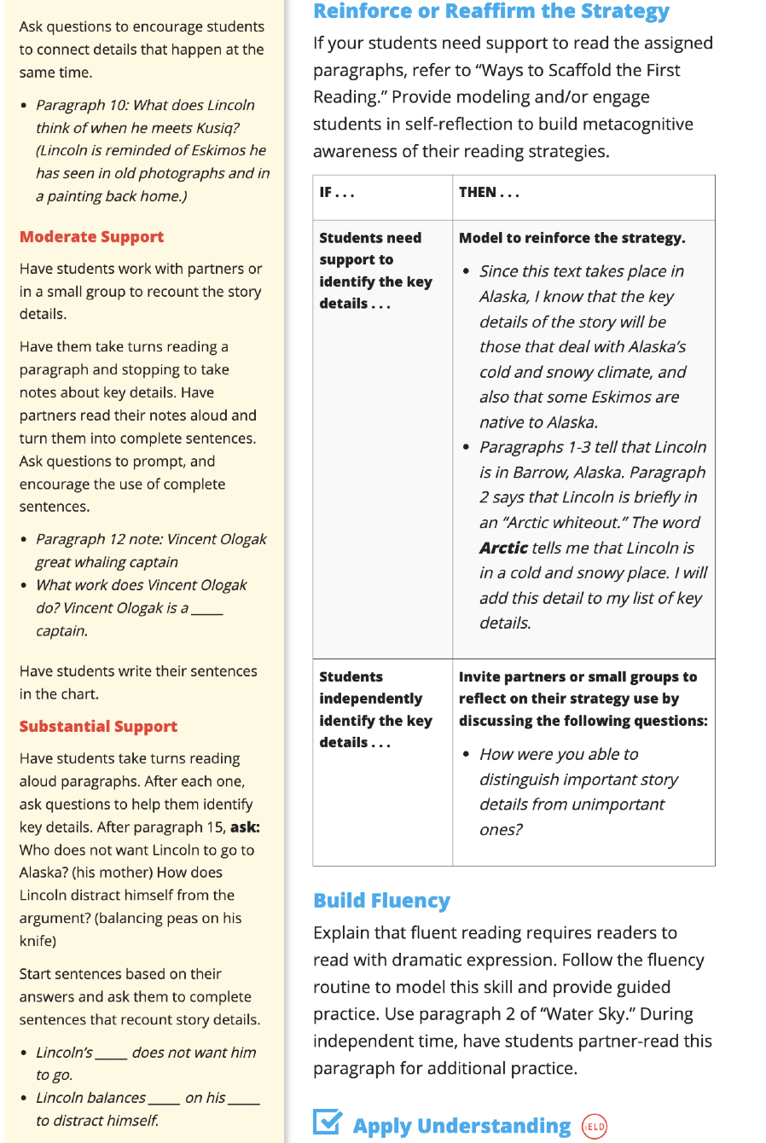
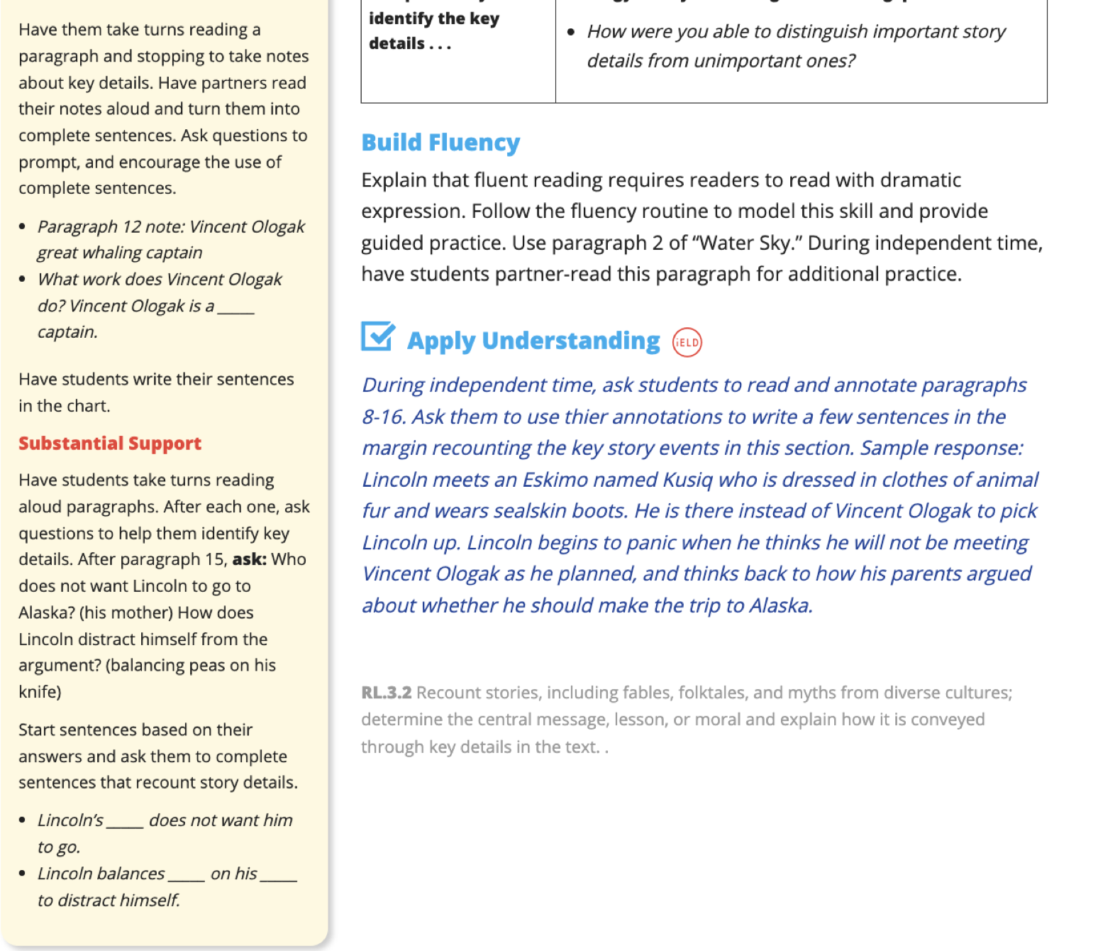
https://itrs-production.benchmarkuniverse.com/#init/f8bf35a86333052d0385e340caa163f01d25ef63/X37633
https://youtu.be/eHCpJ86XDY4?si=w13Dq4efopIvQgC0
© Document developed at UPR Aguadilla by Professor Nydia E. Ugarte Avilés, Supervisor of Teaching Practice. Revised January 2017, integrating basic aspects of Circular Letter No. 03- 2016-2017 of the DEPR.
© Reviewed by Dr. Lissette Hernandez Villanueva according to Circular Letter 02-2019-2020 DEPR and Planning in Line (PeL) 2021, DEPR. August 2022
© Translated by Dr. Alison Torres Ramos, Spring 2023. Revised Fall 2024.

